INTERNSHIP APPLICATION TRACKER (STUDENTS)
@CREATIVITY THINK (9483175986/7019689991)

ABSTRACT:
Internship Application Tracker is a dynamic web-based system designed for students to efficiently organize and monitor their internship or job applications. The platform enables users to add company details, set deadlines, track application statuses, maintain notes, and receive reminders. A dedicated dashboard provides an overview of total applications, interviews, offers, and progress summaries.
Additionally, the system supports an optional administrator or placement coordinator role for viewing aggregated student statistics and exporting data. Built with Django REST Framework and React, this platform offers a structured, intuitive, and data-driven application tracking experience..

INTRODUCTION OF THE PROJECT:
Students often apply to multiple internships or job roles during their final/pre-final years and struggle to track deadlines, statuses, interview outcomes, and follow-up notes. Manual tracking methods like spreadsheets or notes become messy and error-prone.
Internship Application Tracker addresses this need by providing a centralized system where students can log applications, update statuses such as Applied, Interview, Offer, or Rejected, maintain notes, and receive deadline-based reminders. A dashboard visualizes overall progress, helping students stay organized throughout the placement season..

PROJECT OBJECTIVES:

• Provide a structured interface to add and manage internship/job applications
• Allow users to update application statuses with multiple stages
• Maintain notes, feedback, and interview outcomes
• Offer reminder alerts for upcoming deadlines or interviews
• Provide dashboard analytics for overall application progress
• Enable optional placement coordinator to view aggregated stats
• Ensure seamless interaction through Django API + React frontend
• Support exporting summarized data via admin tools

PROBLEM OF THE STATEMENT:
Students applying to several internships face difficulties tracking deadlines, interview schedules, and statuses. Traditional methods like notebooks or spreadsheets do not provide reminders or analytics, causing missed opportunities and disorganization.
The Internship Application Tracker solves these gaps by offering a comprehensive system to log, monitor, and visually analyze all applications in one place..

MOTIVATION OF THE PROJECT:
• To help students avoid missed deadlines during placement seasons
• To give students a centralized system for all their internship/job applications
• To replace unorganized manual tracking methods
• To provide reminders and progress-based insights
• To assist placement coordinators in monitoring overall student activity
• To encourage students to maintain notes and feedback for better preparation

BLOCK DAIGRAM OF PROJECT:

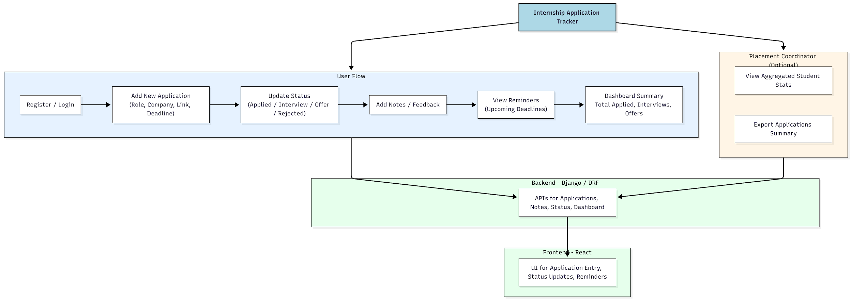

WORKING OF THE PROJECT:
Students register and log into the system to track their internship applications. They can add new applications with details such as company name, job role, link, and deadline. Each application moves through various statuses like Applied, Interview, Offer, or Rejected.
Users can also add personal notes and feedback for future reference. The system highlights upcoming deadlines through reminders. A dedicated dashboard provides summaries like total applications, number of interviews, offers, and status distribution.
Placement coordinators (optional role) can view aggregated statistics for all students and export data in a structured format. Django REST APIs handle data logic, while React ensures a clean, responsive user interface..

SOFTWARE REQUIREMENT:
- Backend:
  - Python 3.x
  - Django
  - Django REST Framework
  - SQLite/PostgreSQL
- Frontend:
  - Node.js and npm
  - React.js
  - Axios
- Development Tools:
  - Visual Studio Code
  - Postman (for testing APIs)
  - Git/GitHub (for version control)
- Server/Deployment (Optional):
  - Gunicorn, Nginx, or Heroku/AWS for hosting

ADVANTAGES OF THE PROJECT:

• Centralized, structured tracking of applications
• Deadline reminders prevent missed opportunities
• Multiple statuses for real-time tracking of progress
• Personal notes help improve preparation and recall
• Dashboard helps visualize success rates and progress
• Placement coordinators can monitor student activity
• Fast and responsive UI with React
• Easy data export through admin features

APPLICATIONS OF THE PROJECT:
• College placement departments
• Students preparing for internships/jobs
• Personal productivity tool for application tracking
• Career guidance and training centers
• Portfolio addition for student developers

REFERENCES:

- Django REST Framework Documentation — Django Software Foundation. Django Documentation. Available: https://docs.djangoproject.com/
- Django REST Framework. DRF Documentation. Available: https://www.django-rest-framework.org/
- React. React Official Documentation. Available: https://reactjs.org/docs/getting-started.html
- Redux. Redux Documentation. Available: https://redux.js.org/introduction/getting-started
- PostgreSQL Global Development Group. PostgreSQL Documentation. Available: https://www.postgresql.org/docs/
- MySQL. MySQL Reference Manual. Available: https://dev.mysql.com/doc/
- Git. Git Documentation. Available: https://git-scm.com/doc
- Node.js. Node.js Documentation. Available: https://nodejs.org/en/docs/
- Axios. Axios Documentation. Available: https://axios-http.com/docs/intro
- Socket.io Documentation – https://socket.io/docs/

